**Lesson 1: SELECT queries 101**

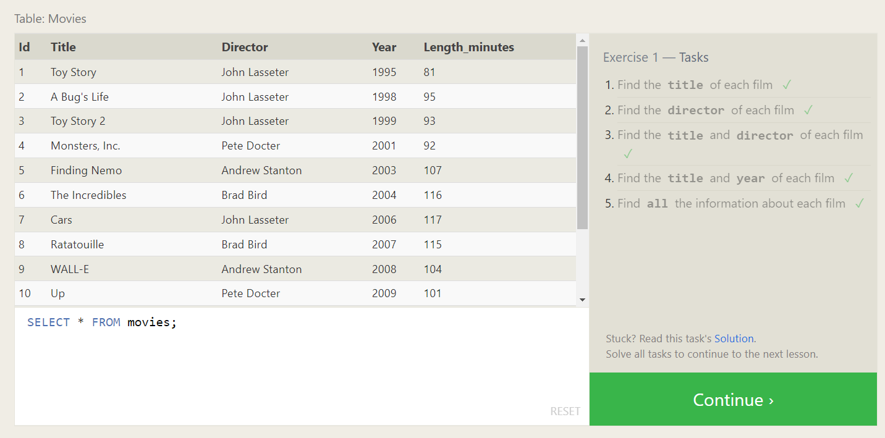

**Lesson 2: Queries with constraints (Pt. 1)**

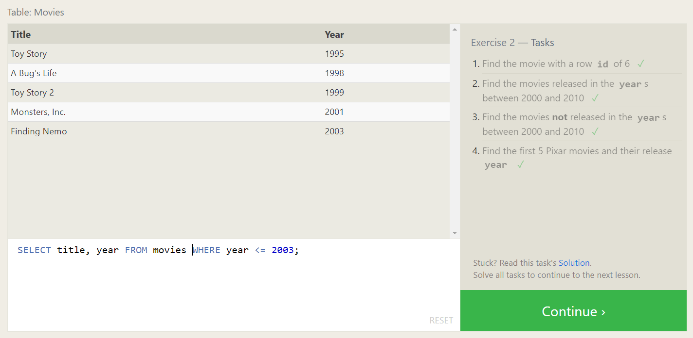

**Lesson 3: Queries with constraints (Pt. 2)**

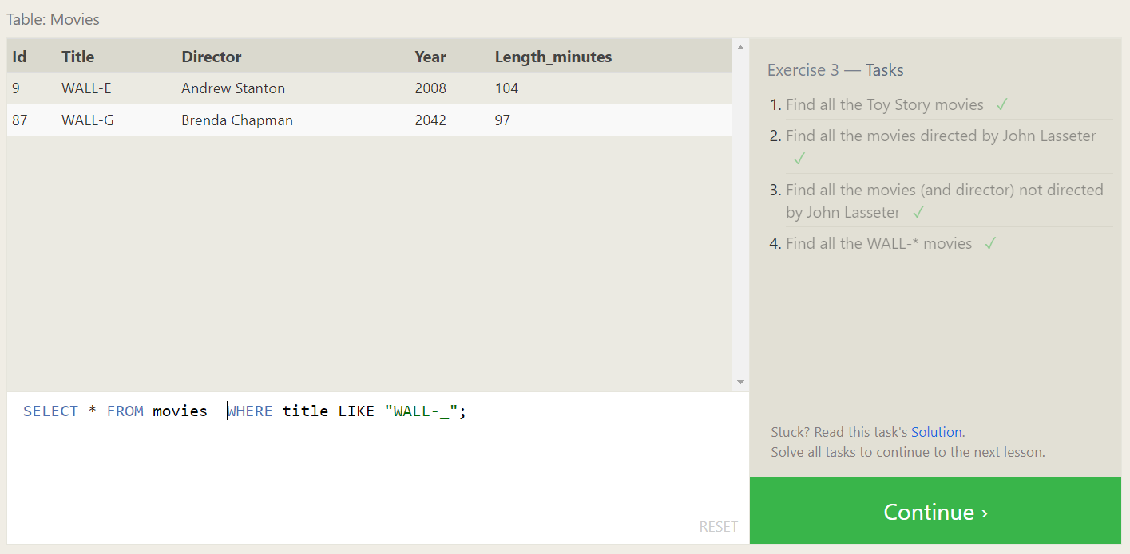

**Lesson 4: Filtering and sorting Query results**

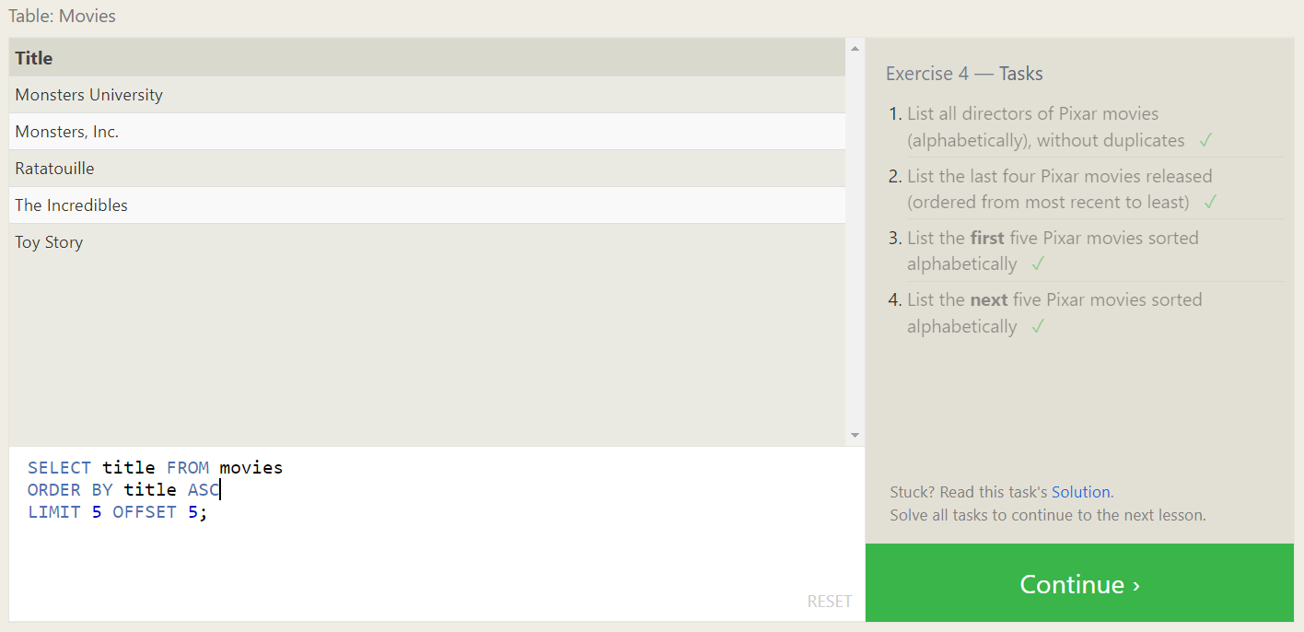

**SQL Review: Simple SELECT Queries**

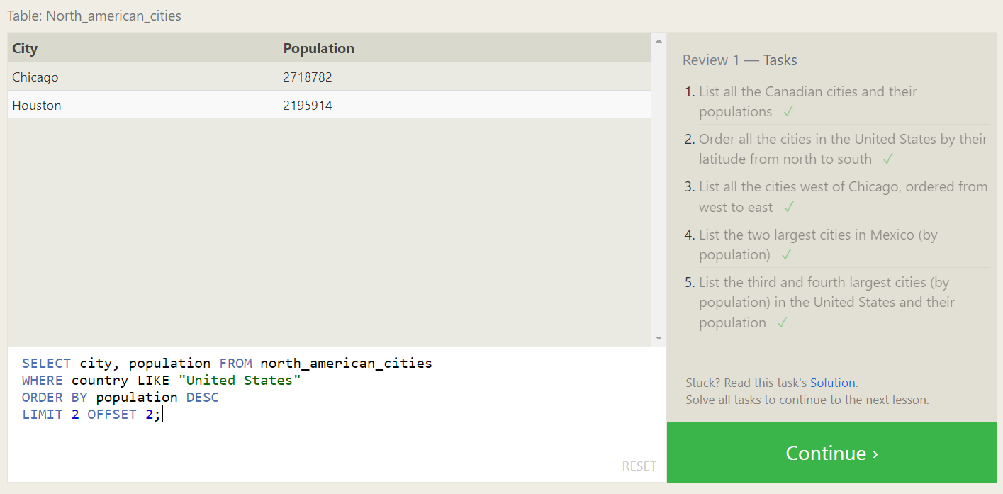

**Lesson 6: Multi-table queries with JOINs**

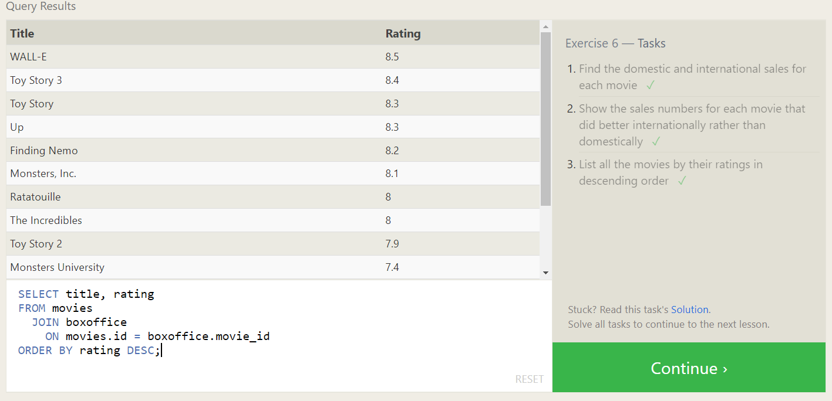

**Lesson 7: OUTER JOINs**

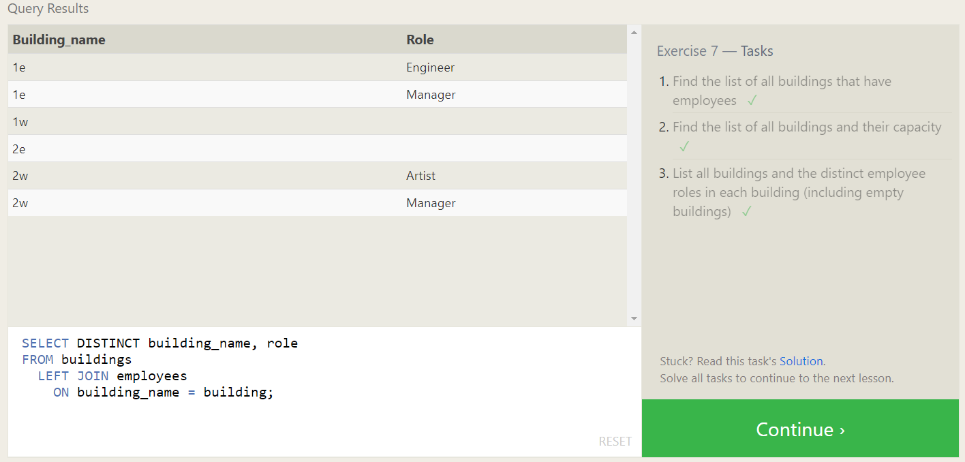

**Lesson 8: A short note on NULLs**

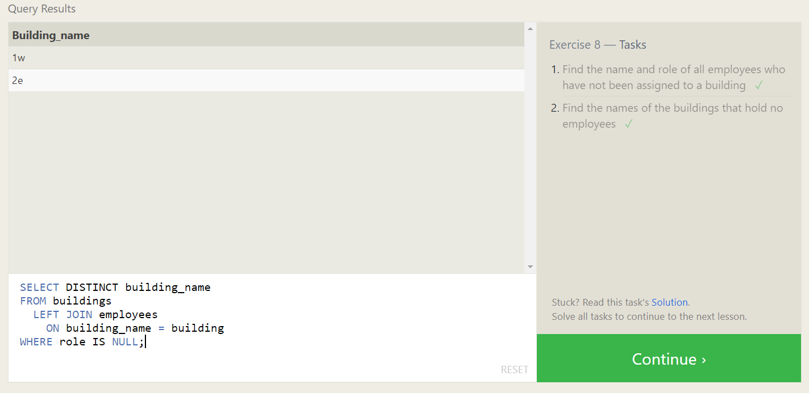

**Lesson 9: Queries with expressions**

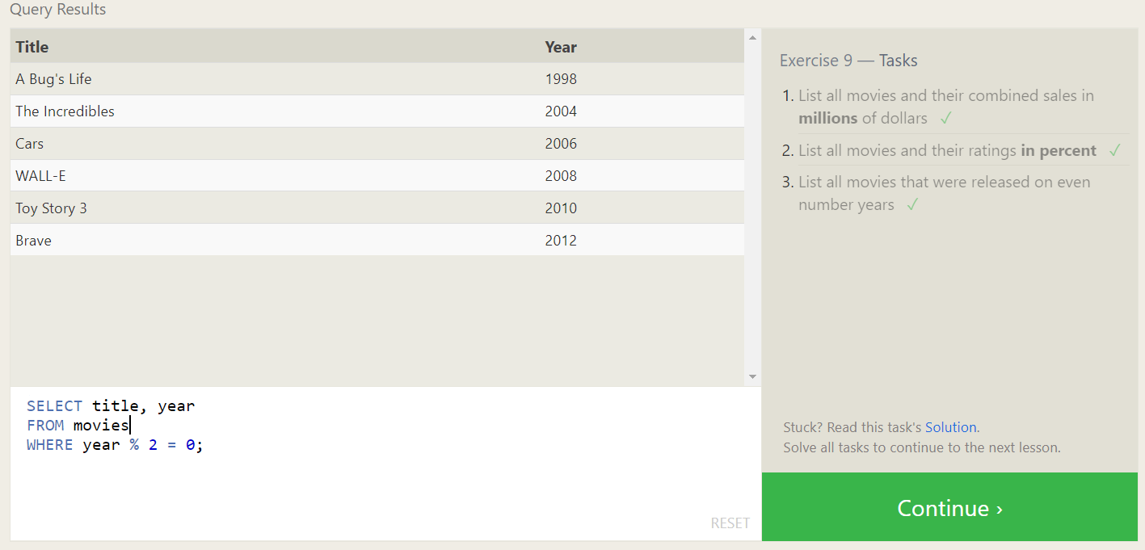

**Lesson 10: Queries with aggregates (Pt. 1)**

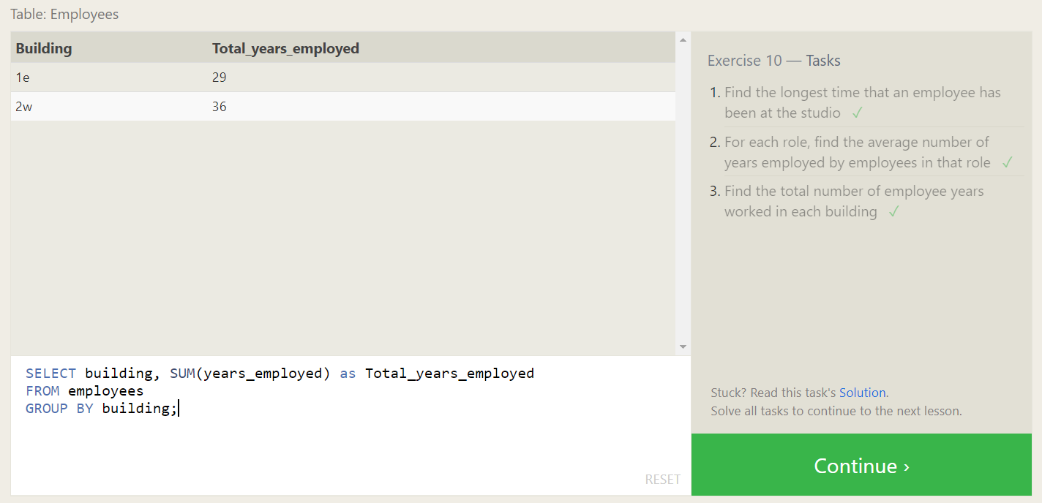

**Lesson 11: Queries with aggregates (Pt. 2)**

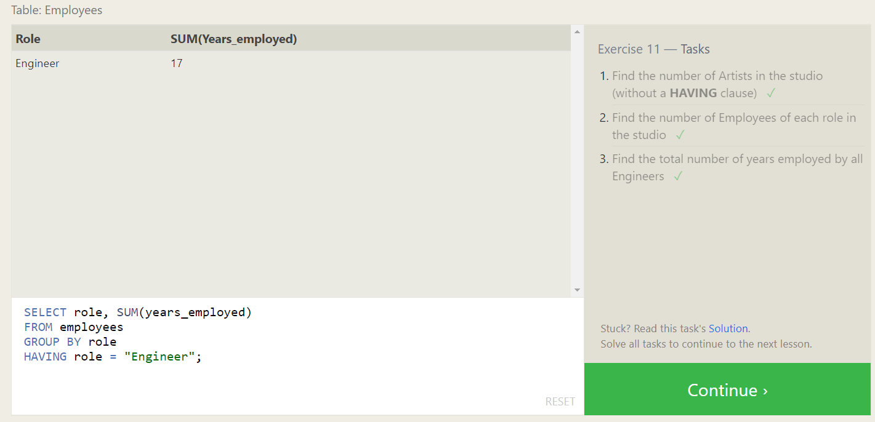

**Lesson 12: Order of execution of a Query**

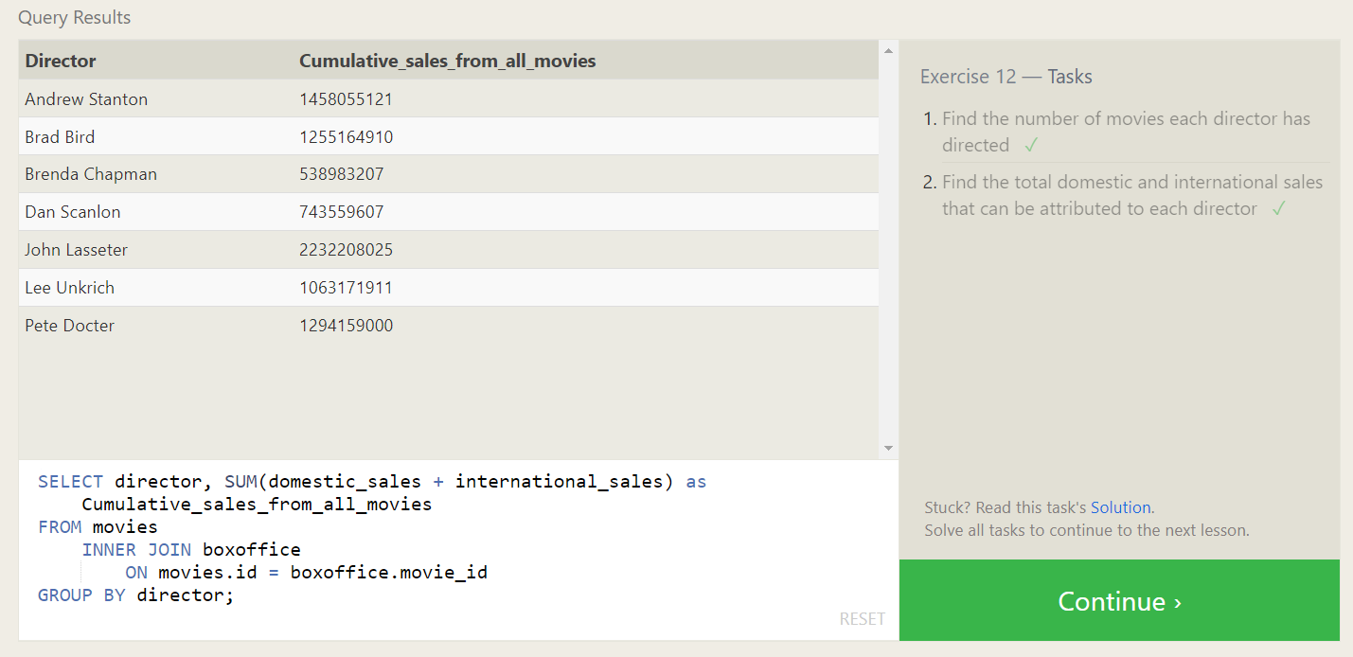

**Lesson 13: Inserting rows**

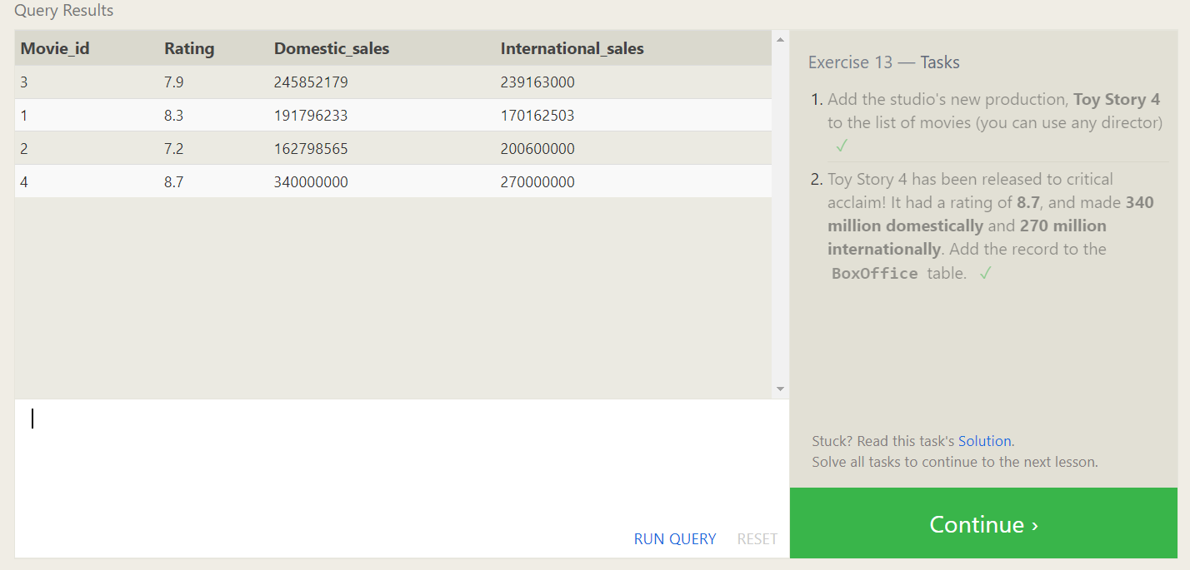

**Lesson 14: Updating rows**

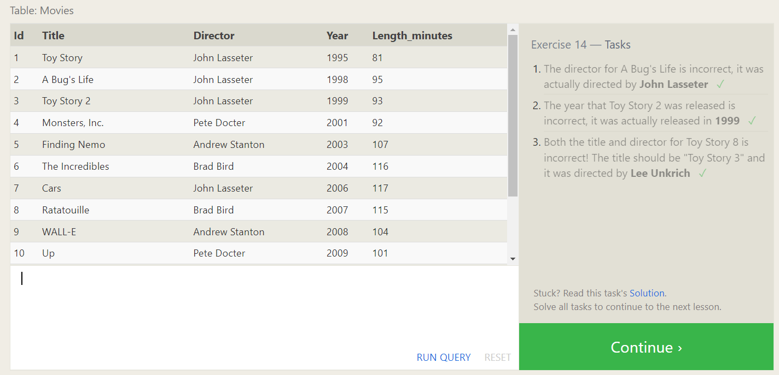

**Lesson 15: Deleting rows**

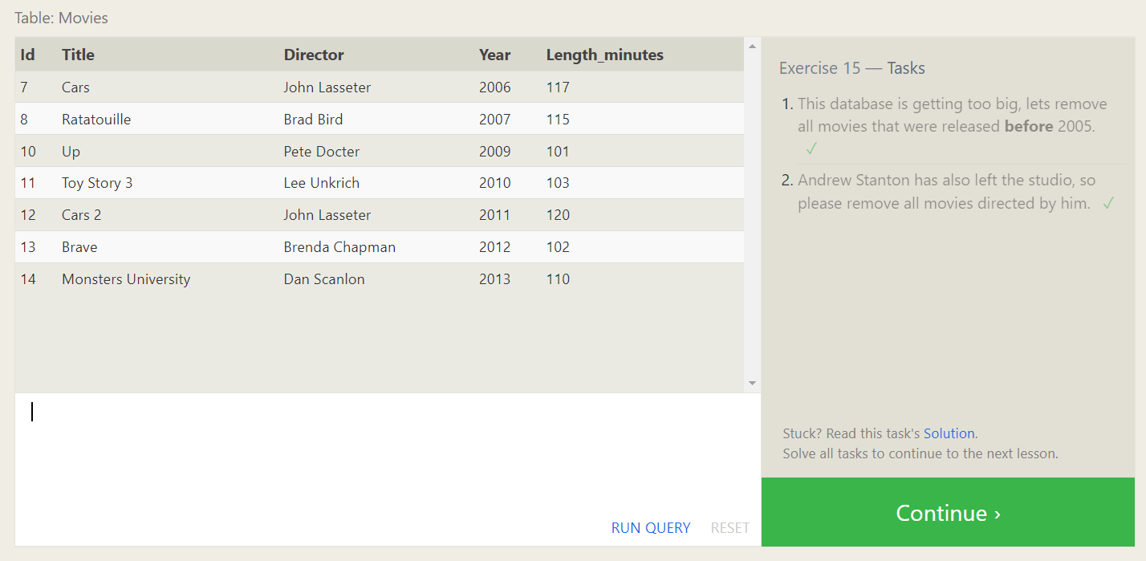

**Lesson 16: Creating tables**

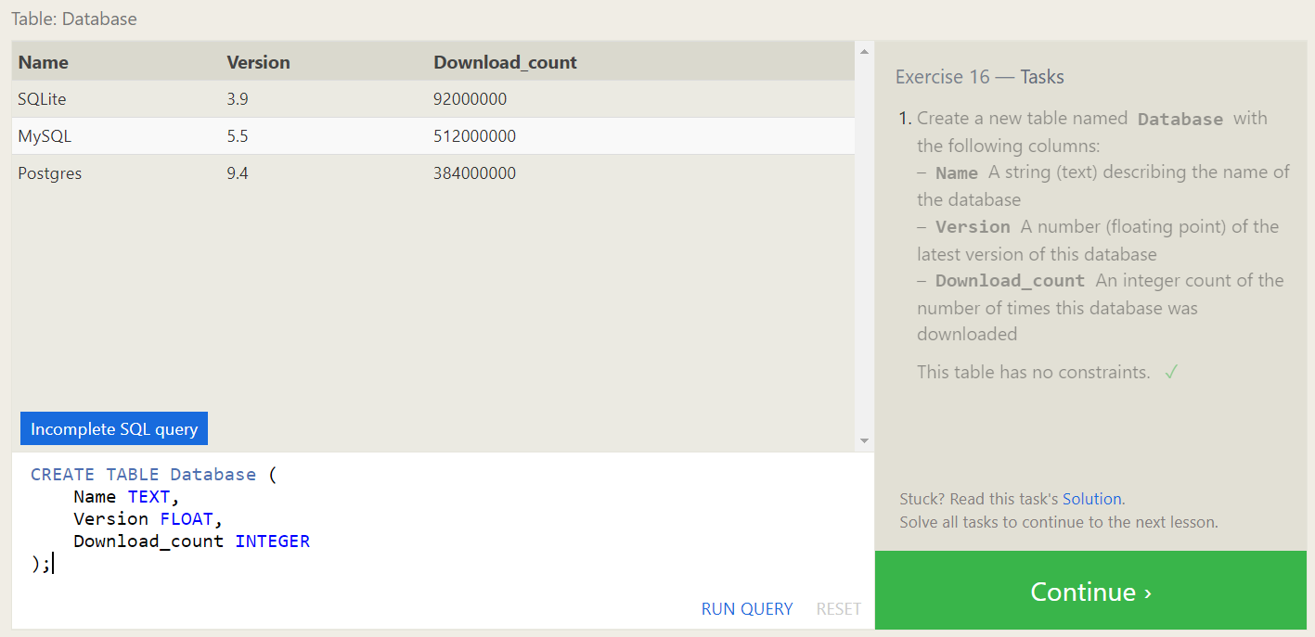

**Lesson 17: Altering tables**

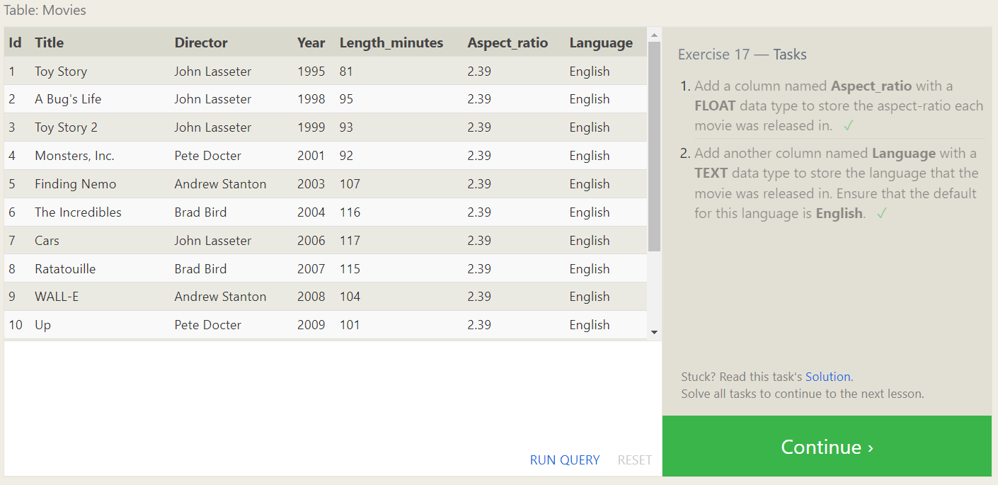

**Lesson 18: Dropping tables**

